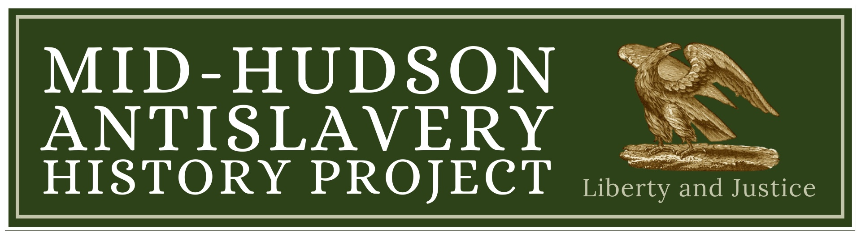
Oh, Freedom! Quilting Exhibition
A project of the Mid-Hudson Antislavery History Project featuring community quilts by local organizations and small art quilts by local artists and members of the Quilt-N-Queens guild. These quilts commemorate the history of slavery and abolition in the Hudson Valley.
Location: Family Partnership Center, 29 North Hamilton St., Poughkeepsie
Times: March 13,12-5, March 14, 9-5, March 15, 11-4, March 20, 9-5, March 21, 9-5
On Saturday, March 15, the Mid-Hudson Antislavery History Project will host a program of music and talks by artists and participating organizations.
Quilting has a history of bringing people together in the creation of art that combines individual expression and group values. We are moved by quilters who have commemorated and honored people both well-known and unrecognized who lived and died for freedom and justice. This project follows in their footsteps.
Participating Organizations: Celebrating the African Spirit, Sadie Peterson Delaney African Roots Branch Library, Oakwood Friends School, The Putnam History Museum, Vassar College History Department
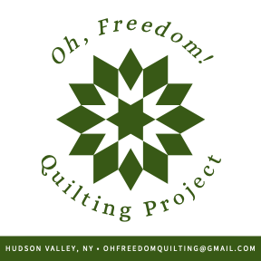For more information: info@mhahp.vassarspaces.net 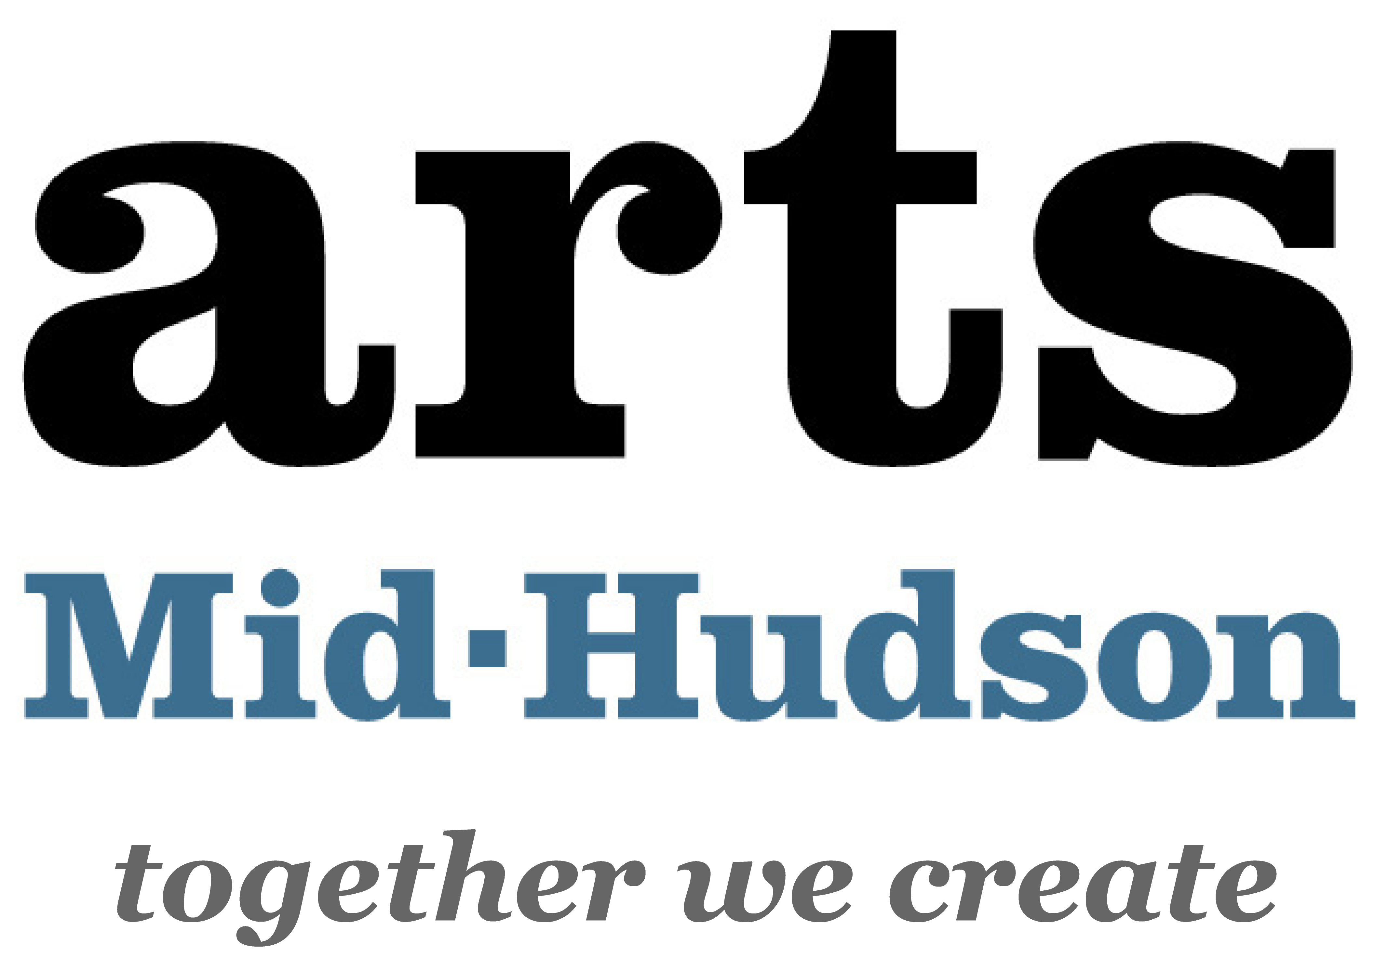
This project is made possible with funds from the New York State Legislature and administered by Arts Mid-Hudson

